Всероссийская олимпиада школьников по предмету
“АНГЛИЙСКИЙ ЯЗЫК”
Задания муниципального этапа 2021/22 уч.г.
для 7-8 классов

LISTENING (approximately 30 minutes)

Part 1

Questions 1-7
For each question, choose the correct answer.

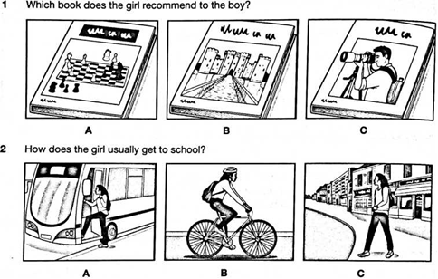

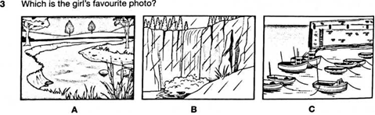

4 Who will be on the TV programme today?

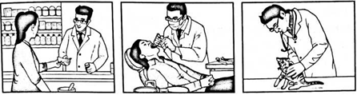

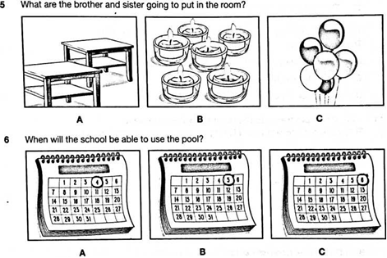
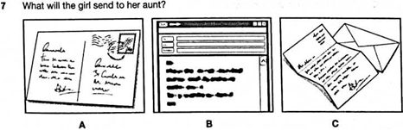

Part 2
Questions 8-13
For each question, choose the correct answer.

8 You will hear two friends talking in a shoe shop.
What does the boy like best about the trainers he wants to buy?
A They're reduced in price.
В They’re a fashionable colour.
C They're comfortable to wear.

9 You will hear two friends talking about a sailing course they went on.
The girl thinks that
A one instructor was better than the others.
В they didn’t make enough progress.
C the race on the last day was unfair.

10 You will hear two friends talking about a new computer game.
They agree that the best way of finding out about new games is through
A friends.
В the internet.
C special magazines.

11 You will hear a boy telling his friend about a football match.
Why is it postponed?
A Several members of the team aren’t able to play.
В The weather today isn’t suitable for playing football.
C The pitch isn’t in good enough condition.

12 You will hear two friends talking about a new podcast.
What do they agree about it?
A It's good for finding out about fashion.
В It's presented in an unusual way.
C It’s more interesting than most podcasts.

13 You will hear two friends talking about their holidays.
They agree that
A it's good to have time to relax on holiday.
В the best way to go on holiday is by plane.
C the coast is better than the mountains for holidays.

Part 3
Questions 14-19
For each question, write the correct answer in the gap.
Write one or two words or a number or a date or a time.

You will hear a teacher telling her students about a trip to a museum.
City Museum trip
The first event will be a talk which lasts around (14) ……......... minutes.
The email address to send questions to is (15) …………. @museum.org.
Groups of students will be able to hold some (16) ............. which are on
display.
In the Technology Centre, students will use (17) ……..…to learn more about ancient objects.
At the end of the visit, there will be a (18) ……………… .
After the trip, students will create (19) ………… for other students to look at.

Part 4

Questions 20-25
For each question, choose the correct answer.

You will hear an interview with a boy called Noah Kelly, who is talking about his love of horse riding.
- Noah started horse riding because
A he was trying to be more active.
В he thought it seemed enjoyable.
C he wanted to lose his fear of animals.
- What is unusual about the horse-riding club that Noah goes to?
A the people who ride there
В its opening hours
C its location
- Noah says that his riding teacher
A knows what to expect from each horse.
В makes sure that riders help each other.
C finds ways to make each lesson fun.
- How has Noah benefitted from horse riding?
A He’s become a more organised person.
В He’s become more patient.
C He’s become fitter.
- Noah says that horse-riding competitions are
A a lot of hard work.
В a good place to make friends.
C easier for people who have their own horse.
- When he’s older, Noah would like to
A enter races.
В work as a horse trainer.
C encourage more children to ride.

